**File Explorer Application**

**High Level design:**

**Objective and Scope:**

**Objective:**

The main goal of this project is to create a C++ console-based file explorer application that works well with the Linux operating system. Through a command-line interface, the application will allow users to carry out necessary file and directory administration activities. This involves looking for files, controlling file permissions, moving, copying, deleting, and creating files. It also involves navigating directories.

**Scope:**

The goal of this project is to create a simple, lightweight console program with the essential file management features that most users need. The program will only run in a Linux environment, interacting with the file system using Linux system calls and the standard libraries in C++. Because of the modular design, every feature including file navigation, manipulation, search, and permission management will be created and tested separately. The project is designed to be finished in five days, with a daily focus on a different set of functionalities, ranging from simple file operations to more complex ones like permission management and file search. This guarantees a step-by-step development procedure that enables comprehensive testing and module optimization. The result will be a powerful, effective tool that can be used straight from the command line to manage files and folders.  
**Architecture Overview**:

The C++ console-based file explorer program's architecture is modular, expandable, and effective, guaranteeing smooth operation with the Linux operating system. This part gives a thorough rundown of the architecture of the program, outlining its key elements, essential modules, and how they work together to produce the intended functionalities.

1. **The user interface (UI)**  
   Using text-based commands, users can interact with the file system through the application's command-line interface (CLI). The CLI's user-friendly design gives users precise instructions and feedback for every action. It can be used to list files, navigate directories, manipulate files, and control file permissions, among other things. The CLI's simplicity ensure that users can pick up on the program fast and use it effectively.
2. **Core Modules:** The design is composed of multiple core modules, each in charge of a particular set of functions. Among these modules are:  
   **FileNavigator:** Directory traversal is handled by the FileNavigator module. It enables users to switch the working directory, navigate through directories, and display the contents of the current directory. It uses system calls from Linux, such as getcwd() and chdir(), to control the directory structure.  
   **File operations**: It is including copying, moving, deleting, and creating files and directories, are handled by this module. To do all these tasks, it makes use of system methods such as open(), read(), write(), rename(), and unlink(). The module provides feedback on successful or unsuccessful operations and guarantees the security of all file manipulations.

**FileSearch:** This module lets users look for files both inside and between folders. It applies recursive search functions, looking through folders and subdirectories and comparing filenames to strings or patterns entered by the user. Utilizing traversal functions like opendir() and readdir(), this is accomplished.  
**PermissionManager:** Users can examine and alter file permissions with the help of the PermissionManager module, which manages file permissions. It retrieves the most recent permissions using the stat() system call, and it applies changes using chmod(). The module offers error handling for invalid inputs and supports standard permission forms, including octal notation.  
**CommandParser:** This module links user inputs to the relevant application actions by interpreting and mapping them. It serves as a link between the main modules and the user interface, parsing commands and invoking methods from the relevant modules.

1. **File System Communication**  
   To communicate with the file system, the application mostly uses Linux system calls. These system calls are employed for tasks such as file modification, permission management, and reading directory contents. The program may effectively manage resources and respond quickly to user commands by making advantage of these low-level features.
2. **Data Flow and Control**  
   Within the application, control and data move in an organized manner  
   **Input Handling:** The CommandParser module processes the input that the user enters via the CLI. This module interprets the command and determines the action that the user has requested.  
   **Command Execution**: The relevant module (such as FileOperations for file manipulations or FileNavigator for directory changes) is assigned the task by the CommandParser. The requested action is subsequently carried out by the chosen module interacting with the Linux file system.  
   **Feedback and Error Handling:** The module returns the result to the user interface after the action is finished. In the event that something goes wrong, the program notifies the user of the problem and offers suggestions for fixing it.
3. **Maintainability and Extension:**  
   The extendable nature of the file explorer application stems from its modular architecture. Modules can be extended or new features introduced without compromising the functionality of the system as a whole. Additionally, this approach improves maintainability by enabling developers to independently update or troubleshoot certain modules, guaranteeing a tidy and well-organized codebase.
4. **Security Considerations:**  
   The architecture places a high priority on security because of the nature of file and directory manipulations. In order to guarantee that actions like file deletion or permission modifications are carried out safely and only on files the user is authorized to modify, the program contains validation checks for user inputs. Furthermore, cautious error handling guarantees that data loss or corruption is not the outcome of system call failures.

3. **Key Functionalities of the File Explorer Application:**

**List of Files:**  
Users can see a list of all the files and folders in the current directory by using the application. This is accomplished by utilizing Linux functions like opendir() and readdir() to read the contents of the directory. Details like file names, kinds (such ordinary files and directories), and perhaps file sizes are included in the output. This feature helps users rapidly identify and access files by giving them a comprehensive picture of the structure of the current directory.  
**Go Through Directories:**  
By going into subdirectories and then back to parent directories, users can navigate the file system. When the user uses commands like cd to change directories, the application keeps note of the current directory path and updates it accordingly. The current working directory can be changed using system functions like chdir(). This characteristic allows users to explore different parts of the file system and access files in various directories.

**File Operations:**  
The program allows for the creation, copying, relocating, and deletion of files as well as directories. System calls such as rename() for file relocation, unlink() for file deletion, and standard file I/O methods for file creation and copying are used to carry out these tasks. From the command line, users may conveniently manage their files, group them into folders, and delete undesirable files.  
**Search Files**:  
Users can search for certain files within a directory or its subdirectories by using the search capability. Recursive directory traversal methods that compare file names to a user-specified pattern are usually used to do this. When searching rapidly for specific files in vast or intricate directory structures, this function comes in handy.

**Manage Permissions:**  
Commands like chmod allow users to examine and change the read, write, and execute permissions of files. The program gives users the essential control over who can access or alter their files by offering a straightforward interface for modifying file permissions. This is essential to preserving file security and guaranteeing that various users have the right amount of access.

**Use Case Diagram:**

An illustration of the interactions between users (actors) and the system (use cases) is called a use case diagram. This is a synopsis of the File Explorer Application's use case diagram.

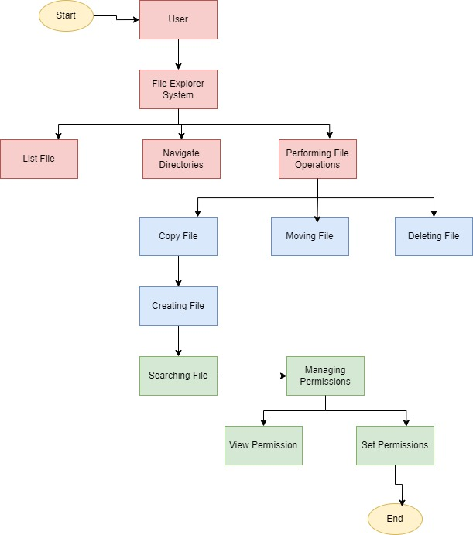

User -> List Files: The user can choose to list files in a directory.

User -> Navigate Directories: The user can move between directories.

User -> Perform File Operations: The user can perform various file operations (copy, move, delete, create).

Perform File Operations -> Copy File/Move File/Delete File/Create File: These specific actions are subsets of file operations.

User -> Search Files: The user can search for specific files.

User -> Manage Permissions: The user can manage file permissions.

Manage Permissions -> View Permissions/Set Permissions: These specific actions are subsets of managing permissions.

This outline and graphic clearly show how a user interacts with the file explorer application, including all of the important features and how they relate to one another.

**Low level Design:**

Low-Level Design

The low-level design of the console-based file explorer application in C++ breaks down the architecture into specific components, classes, methods, and their interactions. This design ensures each functionality is implemented efficiently and logically, providing a clear blueprint for the development process.

**1. Application Structure**

The application consists of several key classes, each responsible for specific tasks. The main classes include FileExplorer, FileNavigator, FileOperations, FileSearch, PermissionManager, and CommandParser. Each class encapsulates related functionalities, promoting modularity and code reusability.

**2. FileExplorer Class**

**Purpose:** Serves as the main controller of the application, managing the overall flow and coordinating between different modules.

**Attributes:**

currentDirectory: std::string: Stores the path of the current working directory.

Methods:

start(): Initializes the application and starts the command loop.

**executeCommand(std::string command):** Calls the appropriate method from other classes based on the parsed command.

**3. FileNavigator Class**

**Purpose:** Handles directory navigation and file listing.

**Attributes:**

**currentDirectory: std::string**: Tracks the current directory's path.

**Methods:**

**listFiles():** Uses opendir() and readdir() to list files and directories in the current directory.

**changeDirectory(std::string newDir):** Changes the working directory using chdir().

**goToParentDirectory():** Moves up one directory level by modifying the currentDirectory path.

**4. FileOperations Class**

**Purpose:** Manages file manipulation tasks like copying, moving, deleting, and creating files.

**Attributes:**

**sourcePath: std::string:** The path of the file to be manipulated.

**destinationPath: std::string:** The target path for copy/move operations.

Methods:

**copyFile(std::string source, std::string destination):** Opens the source file, reads its contents, and writes them to the destination.

**moveFile(std::string source, std::string destination):** Uses rename() to move the file from source to destination.

**deleteFile(std::string path):** Deletes the specified file or directory using unlink() or rmdir().

**createFile(std::string fileName):** Creates a new file in the current directory using standard file I/O.

**5. FileSearch Class**

Purpose: Implements file search functionality within directories.

Attributes:

searchPattern: std::string: The pattern to search for in file names.

Methods:

searchFiles(std::string directory, std::string pattern): Recursively traverses the directory using opendir() and readdir(), comparing each file name against the search pattern.

6**. PermissionManager Class**

Purpose: Handles viewing and modifying file permissions.

Attributes:

filePath: std::string: The path of the file whose permissions are to be managed.

Methods:

viewPermissions(std::string path): Uses stat() to retrieve and display the file's current permissions.

b Applies new permissions to the file using chmod().

1. **CommandParser Class**

**Purpose**: Parses and interprets user commands, mapping them to appropriate methods.

**Attributes:**

**command: std::string:** The raw user input command.

Methods:

**parseCommand(std::string command):** Breaks down the command into action and arguments.

**getCommandType():** Determines the type of command (e.g., navigation, file operation) and returns the corresponding method to be executed.

**8. Flow of Execution**

**Initialization:** The application starts by setting the currentDirectory to the user's home directory or another default path.

**Command Loop:** The FileExplorer class runs a loop, prompting the user for input. The input is passed to the CommandParser, which parses the command and invokes the corresponding method from FileNavigator, FileOperations, FileSearch, or PermissionManager.

**Command Execution**: Based on the command type, the relevant class method is called to perform actions like listing files, navigating directories, or modifying files.

**Error Handling:** Each method includes error handling to manage invalid inputs, permissions issues, or file system errors. The application provides feedback to the user on successful or unsuccessful operations.

**9. Security and Permissions**

The application ensures that file operations respect Linux file permissions. It checks whether the user has the necessary rights before performing actions like deleting or modifying files. If a user lacks the required permissions, the application provides a suitable error message.

This low-level design provides a thorough foundation for building the console-based file explorer in C++ by outlining the main components of the application and how they interact with one another. It guarantees flexibility, modularity, and ease of maintenance, enabling the integration of new features without interfering with the architecture as a whole.